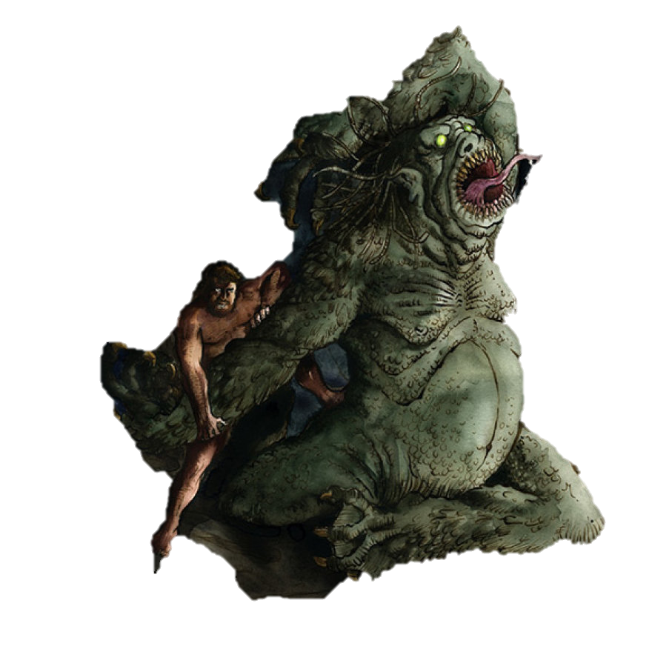

‘an enemy from hell itself’ ‘monster’ ‘sworn enemy of God and men’

‘beast born of evil and shame’ ‘enraged’ ‘evil heart’ ‘violent’

‘filled with fury’ ‘terrible slaughter’ ‘murdered in bloodlust’

‘feasted of their blooded corpses’ ‘fatal fiend of the darkness’ ‘stalked’

‘hellish monster’ ‘ killed without mercy’ ‘banished all happiness’

‘stalker of the night’ ‘thirsty to kill’ ‘terror-tyrant’

‘fire-blazing eyes’ ‘creature’ ‘killing claws’ ‘demon of the night’

‘mossy green scales’ ‘serpent tongue’ ‘blood stained claws’

‘breath plagued with corpses’

‘hair tangled and drenched in blood’

‘colossal’ ‘pointed ears’ ‘drooling lips’

‘knobbly knees’ ‘ crawled’

‘blood-thirsty’ ‘inhuman’