Reading homework – clouds
This week, we will read chapter 3 from the fiction express website. You can access this site using any device which can access the internet.
If you scan the QR code with your phone camera, you can watch a tutorial to learn how the fiction express website works.

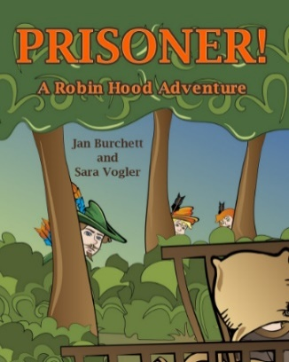
We are currently reading:
Prisoner! A Robin Hood adventure (level 1)

This week, complete these 3 tasks:
- Read chapter 3
- Vote for the next chapter
- Complete the reading quiz (questions about the chapter)

Reading homework – clouds
This week, we will read chapter 3 from the fiction express website. You can access this site using any device which can access the internet.
If you scan the QR code with your phone camera, you can watch a tutorial to learn how the fiction express website works.

We are currently reading:
Prisoner! A Robin Hood adventure (level 1)

This week, complete these 3 tasks:
- Read chapter 3
- Vote for the next chapter
- Complete the reading quiz (questions about the chapter)

Reading homework – moons and stars
This week, we will read chapter 3 from the fiction express website. You can access this site using any device which can access the internet.
If you scan the QR code with your phone camera, you can watch a tutorial to learn how the fiction express website works.
We are currently reading:
Truth or dare (level 2)

This week, complete these 3 tasks:
- Read chapter 3
- Vote for the next chapter
- Complete the reading quiz (questions about the chapter)

Reading homework – moons and stars
This week, we will read chapter 3 from the fiction express website. You can access this site using any device which can access the internet.
If you scan the QR code with your phone camera, you can watch a tutorial to learn how the fiction express website works.
We are currently reading:
Truth or dare (level 2)

This week, complete these 3 tasks:
- Read chapter 3
- Vote for the next chapter
- Complete the reading quiz (questions about the chapter)

