Year 4 – A week of Creative Learning Fun for May Half Term 2020
Select some of these fun activities during the Half Term break.
Record anything you do in your home learning book and we’d love to see photos and videos of what you do/make! Have fun!!
Take a virtual tour!  Take a tour of your favourite place, maybe the British Museum, Stonehenge or even Mars!  https://www.goodtoknow.co.uk/family/best-virtual-tours-for-kids-536089 | Make a bird feeder ...  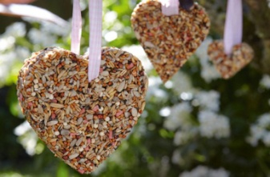  With plenty more wildlife now visiting gardens due to the warmer weather, watch the different birds flock to your bird feeder!  https://www.goodtoknow.co.uk/family/things-to-do/how-to-make-a-bird-feeder-291299 | Do some magic!  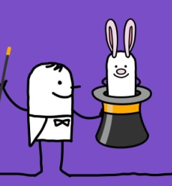  Impress your friends by learning a few magic tricks!  https://www.thesprucecrafts.com/magic-tricks-for-beginners-and-kids-2267083
Set a record!  Try to skip 100 times without stopping! Or something else!!  https://www.guinnessworldrecords.com/world-records/79085-most-skips-in-one-minute | Use a secret code!  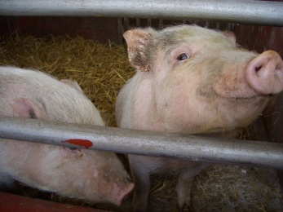  Use Pig Pen to write a secret message!  https://www.mykidstime.com/things-to-do/how-to-write-a-secret-message-using-the-pigpen-cipher/ | Wash the car!  Not too exciting, but in warm weather this is great fun if you put on your swim togs, get out the garden hose, use warm soapy water to start with and get cleaning the car! Have a good old time messing about with water, and your grown ups will be pleased!
Bubble engineering!  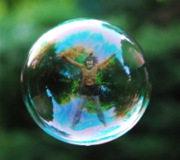  Build 3-dimensional bubble wands and make an inverted bubble cube or other shaped bubble.  https://babbledabbledo.com/science-engineering-kids-tensile-bubbles/ | Record bees and help Science!  Help Friends of the Earth by recording bee sightings! These will help scientists get a better understanding of the numbers and species that we need to protect. Remember to keep your distance!  https://friendsoftheearth.uk/bee-count/bee-surveys-record-bees-and-help-science | Practise your Spanish vowel sounds with this fun clapping game!  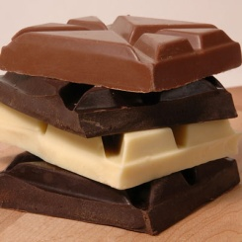  You’ll need a partner, but could always practise with a teddy!  https://www.spanishplayground.net/hand-clapping-games-spanish-mariposa-chocolate/

